Buying things in prison

Unit 3

The canteen sheet

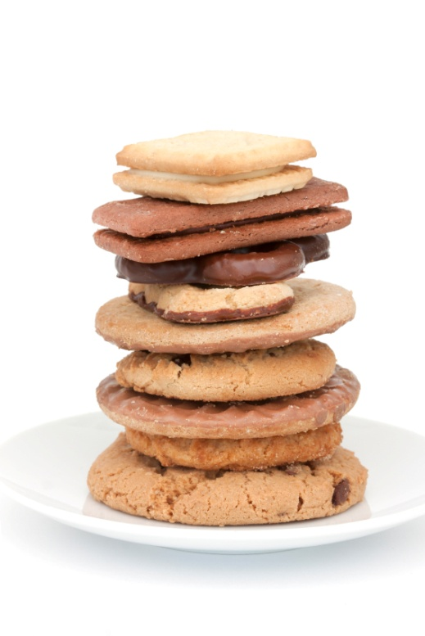
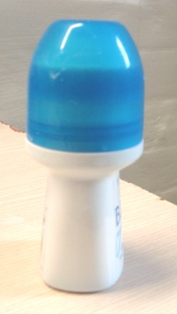

Contents

Unit 3 The canteen sheet teacher’s notes

Unit 3 The canteen sheet learner resources

Unit 3 The canteen sheet additional resources for teachers

Unit 3 The canteen sheet answers
Unit 3 Canteen sheet: Teacher’s notes
The vocabulary focus of the activities in this unit is based on a sample canteen sheet from a prison in the UK. It would be better to use the canteen sheet at your establishment as learners will be more familiar with the version they use on a regular basis.
Time: Approximately 90 minutes. Timings are flexible and it could take longer than this.
Level: Entry level 1-3 / Scottish National 2 – National 4 / CEFR A1 - B1

Aims

- To build learners’ vocabulary to enable them to use a canteen sheet.
- To introduce language for asking for and giving opinions on food and dietary requirements.
- To provide the opportunity for learners to discuss different diets.
- To build confidence in using different reading strategies to read and make sense of the canteen sheet.

Objectives
All learners will be able to:
- understand the headings and some key vocabulary on a canteen sheet
- scan for detail on a canteen sheet
- describe some key items on a canteen sheet
- describe the differences between different dietary requirements
- ask and answer questions about dietary requirements
- use correct word stress in questions and answers.
Some learners will be able to:
- describe the difference between ‘essential’ and ‘non-essential’ items on a canteen sheet.
Preparation
You will need:
- Resource 1 for lead in task: to display on interactive whiteboard or one per small group
- Canteen sheet from your prison
- Resources 2 and 3 resource cards (to be photocopied as A3, laminated if possible, and cut up) per group
- Resource 4 canteen sheet categories, one per learner
- Resource 5 diet quiz, one per learner
- Resource 6 pair activity, sheets A and B per pair
- Resource 7 class survey, one per learner

Suggested Procedure

Lead in
- Introduce the focus of the session. Show pictures of some of the key items on a canteen sheet using resource 1 to elicit what learners already know about using the canteen sheet and how confident they are ordering from it. You could ask learners what they have bought recently and how they order what they want.

Activity 1: Vocabulary definition game
- Introduce the activity and put learners into pairs/3s.
- Hand out the cards cut up from resources 2 and 3 to each pair/3. Ask learners to match the words and definitions. Clarify any new vocabulary, e.g. unpleasant, snack.
- Encourage learners with good literacy to help those who struggle with reading.
- Play the ‘definition game’. Give each pair/group a pile of word cards. Each learner takes it in turn to take a card and describe the item; their partner/group has to guess what it is. The learner who guesses correctly takes the card and the winner is the one with the most cards. Alternatively, depending on the number of learners, this could be a team game.
- Language note: before starting, recap/revise the language needed for describing items, e.g. ‘You use it for washing’ or ‘You use it to wash your hands’. Use this as an opportunity to assess learners’ spoken accuracy and identify areas to work on in future.

Differentiation: for lower level groups (or those with literacy needs), select the word cards and definitions that would be most useful for them. Stronger learners could be asked to write their own definitions of some of the items.

Extension tasks: a) the game can be reversed with learners reading out the definitions and guessing the item; b) the vocabulary cards can be used for spelling practice, using the Look, Say, Cover, Write, Check technique. (Templates for this can easily be found online and printed off for use in class.)

Activity 2: Canteen sheet headings and items
- Hand out resource 4 and check understanding of the categories orally by eliciting an example for each one. Then ask learners individually to write down two or three items they have ordered/would like to order in each category. Monitor and check items are in the correct category. Help with spelling and note difficulties for follow up work.
- When they have finished, learners compare their list with a partner and discuss reasons for their choices, e.g. ‘Why did you choose …?’ ‘How often do you order …? ‘Because I need some …’ ‘Because I really like …’ ‘I order … every week’, etc. Monitor the activity and assess whether learners use question forms correctly. Note for follow up work.
- Next ask learners to guess and write down the price next to each item they have chosen.
- Give learners a copy of the prison canteen sheet and ask them to scan it to find the items on their own lists and to check if they have guessed the prices correctly. Encourage learners to work together and help each other to find the items.

Differentiation: Ask early finishers to choose and write down five ‘essential’ and five ‘non-essential’ items from the prison canteen sheet. Then they can compare their list with a partner and jointly decide on the five most essential and non-essential items. Encourage learners to give reasons for their decisions.

Extension tasks: Ask stronger/faster learners to scan the canteen sheet ‘Groceries' section to find the following abbreviations: Klg, Econ, Inst N/dle, Hlvs, P/apple, Evapo, Crmd, and to guess what they stand for. If your group enjoys competitive tasks, you could do this in small teams and they race against the clock to find the abbreviation, one at a time.

Activity 3: Different diets quiz
- Ask if any of the learners have a special diet (or know someone who does). If so, ask them to explain what they can/can’t eat and why it is important to them. If no-one has a special diet, write the words ‘vegetarian’ and ‘halal’ on the board, and elicit the meanings.
- Hand out resource 5. Fold over the diet terms at the bottom of the sheet for stronger learners. Ask learners to work in pairs/3s to decide the answers. Let learners who are finding it difficult to unfold the paper and choose from the terms given.
- Ask them to compare their answers with another pair/3.
- Ask learners to ask each other the follow up questions and record their partner’s answers. Feed back their ideas to the whole group and use this as a springboard for a discussion on how prison menus cater for their needs.

Extension task: Identify the stress patterns of all the diet words: vegan, gluten, sugar, healthy option, kosher. (Note: the stress falls on the first syllable in these words as there is a general tendency in English to stress two-syllable nouns and adjectives on the first syllable.)

Activity 4: Different diets (speaking activity)
- This is an ‘information gap activity’ – learners work in pairs to ask for and give information in order to complete their resources.
- Introduce the activity and explain to learners that they will need to listen carefully and give information clearly.
- Put learners into pairs - A and B - and give each learner either Resource 6 (Learner A) or Resource 6 (Learner B).
- Explain to learners that they are going to be asking about the type of food that is on the canteen sheet. This appears as abbreviations.
- With a quick-fire Q and A, recap what the letters ‘V’, ‘Ve’, ‘GF’, ‘H’, ‘HO’, ‘K’ stand for. Elicit synonyms from stronger learners for the word ‘Option’ in Healthy Option (suggested answers: choice, selection).
- Demonstrate the activity with a strong pair first.
- Learners take it in turns to ask for/give information to complete their sheets.
- Monitor the activity and note areas of difficulty for follow up work.
- When they have finished, ask them to compare sheets to check they have filled in the information correctly.

Activity 5: Buying items on canteen sheet
- Tell learners to imagine they have £5 to spend.
- Using their prison canteen sheet (or a section of it, depending on the levels in your group), tick at least 6 different items they would like to order and total the cost. Afterwards, ask ‘Who has bought the most items for £5? Which item was the most expensive/cheapest?’
- Mingle activity: using Resource 7, learners walk around and interview five or six other learners about their choices, asking and answering questions about the most expensive/cheapest items they have chosen.
- Before they start, model/drill a few questions and possible answers, noting the stress and falling intonation pattern of the ‘what/why’ questions.
- Encourage learners to use natural pronunciation as far as possible, stressing key content words. For example:

Which was your most expensive/cheapest item? | Milk chocolate Hobnobs
How much was it/were they? | £1.85
Why did you choose it/them? | Because I really love them!

- You could use this as an opportunity to revise/practise comparative and superlative structures.
- Encourage stronger learners to give reasons using a wider range of structures and verbs.
- Feedback: ask each learner to report back on another learner.

Cooler
There are different options, depending on your learners’ levels and interests:
a) dictate some of the words from Activity 1 for spelling practice;
b) write some incomplete words from the lesson onto the board to play a smiley face version of hangman or
c) in pairs to challenge each other to beat the clock and scan the canteen sheet for an item they choose for their partner.

Unit 3 Resource 1 Things on the canteen sheet

Resource


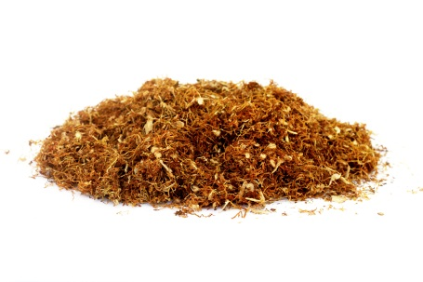



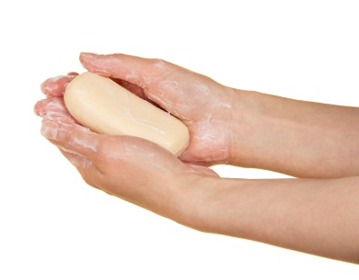

Unit 3 Resource 2
Activity 1 Vocabulary definition game

Phone card | Sweets
Tobacco | Chocolate
Rislers | Peanuts
Toothbrush | Crisps
Toothpaste | Tea bags
Hair comb | Sugar
Soap | Apples
Shower gel | Biscuits
Deodorant | Envelope
Shampoo | Writing pad

Unit 3 Resource 3
Activity 1 Vocabulary definition game: Resource Cards – definitions
small card used to make a phone call | small pieces of sweet food made of sugar
dried leaves smoked in cigarettes and pipes | sweet brown food made from cacao beans
papers for making roll ups | nuts with thin shells, eaten as a snack
small brush for cleaning your teeth | a snack made from thin slices of fried potatoes
a substance used with a toothbrush to clean your teeth | tea leaves in a bag
something you use to tidy your hair | something to make food or drink taste sweet
something you use to wash your body | round, green or red fruit
liquid soap for washing yourself in the shower | small, flat, sweet cakes
something you use to stop unpleasant bodily smells | thin paper cover, used to enclose a letter
liquid soap for washing your hair | sheets of paper put together for writing

Resource 4
Activity 2 (Canteen sheet categories) Learner resource
Write down two items you would like to order in each category.
BATTERIES
TOBACCO
PHONE & STAMPS

………………………… …………………………. ………………………
………………………… …………………………. ………………………
DRINKS
SWEETS & SNACKS
TOILETRIES & HEALTH

………………………… …………………………. ………………………
………………………… …………………………. ………………………
BISCUITS & BAKERY
CARDS
FRUIT & VEGETABLES

………………………… …………………………. ………………………
………………………… …………………………. ………………………
GROCERIES
SUPPLEMENTS
STATIONERY

………………………… …………………………. ………………………
………………………… …………………………. ………………………
SPECIAL OFFERS
RELIGIOUS ITEMS
GENERAL ITEMS

………………………… …………………………. ………………………
………………………… …………………………. ………………………

Resource 5
Activity 3: Different diets quiz
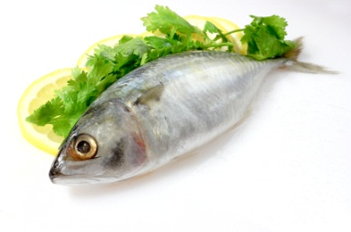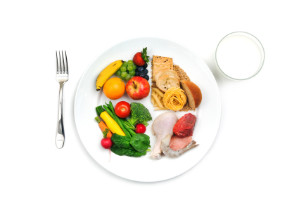

- What do we call someone who does not eat meat or fish?

- What kind of meat comes from an animal that has been killed according to Islamic law?

- What do we call someone who does not eat any animal, fish or dairy produce?

- What do we call food that is prepared according to the rules of Jewish law?

- What is a way of buying and selling products so that the people who produce the goods receive a fair price?

- What do we call food that does not contain wheat, barley or rye?
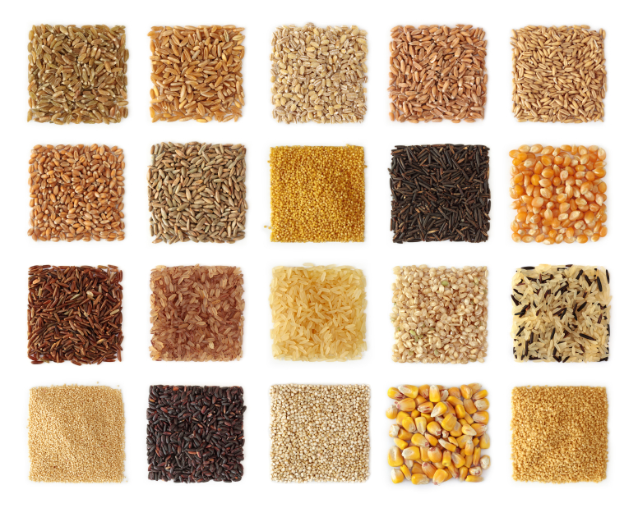

- What adjective (describing word) means food does not have
sugar in it?

- What adjective do we use to say food or diet is good for you?

Now ask a partner the questions 1 and 2 and write down their answers.

- Do you have a special diet? Why?

- Which diet do you think is best for you?

------------------------------------------------------fold here ------------------------------------------------------------

vegetarian vegan halal Fair Trade
gluten-free sugar-free healthy kosher
Resource 6
Activity 4 Different diets (Learner A)
Ask Learner B questions to fill in the missing information about diets in the canteen sheet below. Learner B will also ask you questions.
To begin, ask ‘What is Haribo Starmix Bag?’
V – Vegetarian Ve – Vegan H – Halal GF – Gluten Free HO – Healthy Option K – Kosher

Sweets & Snacks
Haribo Starmix (……)
Cadbury Crunchies (V, GF)
Snickers Bar (…., …., ….)
Polo Original (Ve, H)

Fruit & Vegetables
Banana (….)
Apples (HO)

Biscuits & Bakery
Ritz Original 200g (….)
Fruit Flapjack (K)
Malt Loaf (….)

Groceries
Cornflakes 500g (V, K, H)
Chicken Hotdog 400g (….)
Instant Noodle Curry 85g (V)
Baked Beans 415g (…., …., ….)
Evaporated Milk (V, H)

When you have finished, compare your lists to check you have filled in the missing information correctly.
Resource 6
Activity 4 Different diets (Learner B)

Ask Learner A questions to fill in the missing information about diets in the canteen sheet below. Learner A will also ask you questions.
To begin, ask ‘What are Cadbury Crunchies?’
V – Vegetarian Ve – Vegan H – Halal GF – Gluten Free HO – Healthy Option K – Kosher

Sweets & Snacks
Haribo Starmix (GF)
Cadbury Crunchies (…., ….)
Snickers Bar (V, K, H)
Polo Original (…., ….)

Fruit & Vegetables
Banana (HO)
Apples (….)

Biscuits & Bakery
Ritz Original 200g (V)
Fruit Flapjack (….)
Soreen Malt Loaf (V)

Groceries
Cornflakes 500g (…., …., ….)
Chicken Hotdog 400g (H)
Instant Noodle Curry 85g (….)
Baked Beans 415g (V, GF, K)
Evaporated Milk (…., ….)

When you have finished, compare your lists to check you have filled in the missing information correctly.
Resource 7
Activity 5 Buying items on canteen sheet
Interview three learners about their choices and fill in the form below.
Practise some questions before you start, e.g. What did you choose? Why? Which was your most expensive item? Which was your cheapest item?
Name | Items | Cost | Reason for choice
1.

2.

3.

Now write two or three sentences about one person’s choices.
………………………………………………………………………………………………………….
…………………………………………………………………………………………………………..
…………………………………………………………………………………………………………..

Unit 3 Canteen Sheet answers
Activity 2 Abbreviations
Klg = Kellogs, Econ = Economy, Inst N/dle = Instant Noodle, Hlvs = Halves, P/apple = pineapple, Evapo = evaporated, Crmd = creamed

Activity 3 diet quiz
- vegetarian
- halal
- vegan
- kosher
- Fair Trade
- gluten- free
- sugar- free
- healthy

Activity 4 missing information
SWEETS & SNACKS
Haribo Starmix (GF)
Cadbury Crunchies (V, GF)
Snickers Bar (V, K, H)
Polo Original (Ve, H)
FRUIT & VEGETABLES
Banana (HO)
Apples (HO)
BISCUITS & BAKERY
Ritz Original 200g (V)
Fruit Flapjack (K)
Soreen Malt Loaf (V)
GROCERIES
Cornflakes 500g (V, K, H)
Chicken Hotdog 400g (H)
Instant Noodle Curry 85g (V)
Baked Beans 415g (V, GF, K)
Evaporated Milk (V, H)

